TAKWIM AKADEMIK BAGI TAHUN 2007/'08
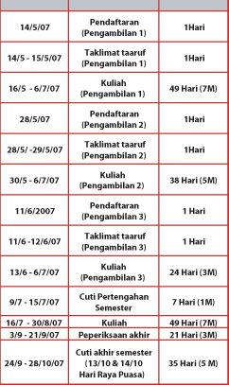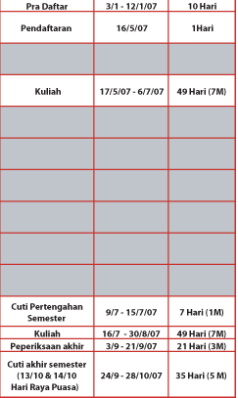
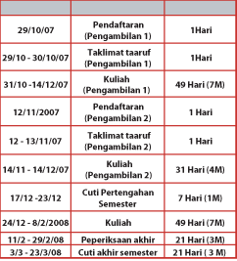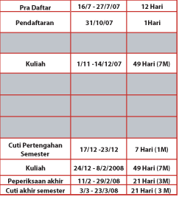

TARIKH - TARIKH PENTING PELAJAR LAMA KUIS SESI MEI 07/08 /
IMPORTANT DATES OF SIIUC SENIOR STUDENT SESSION MEI 07/08
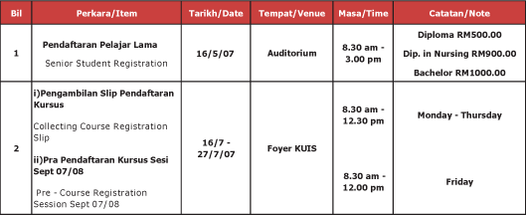
17/5 - 18/5/07 - No Course Registration on this date.
Course Registration will be continue on 21/5/07
17/5 - 18/5/07 - Penalty for late registration

